Monitoring the Construction of a Deep Energy-from-Waste Bunker in Soft Clay and Peat
Peter J. Hensman, Zhandos Y. Orazalin and Brian B. Sheil
29 November 2022

EDITOR
Thank you for submitting your paper to Géotechnique. Following external peer review, your paper has been carefully considered by the Editorial Panel and requires major revision before it can be considered for publication. I enclose the comments received from external peer review at the bottom of this message. Please revise your article, taking these into account, and resubmit a revised version, along with a letter detailing, point by point, the changes you have made (or not made and why). Please try to include the highlighted changes (highlight in yellow) in the revised document to further outline and show the changes made. I would be grateful if you would resubmit your article by 20-12-2022. If you do not wish to make the necessary revisions or cannot realistically make this date, please do not hesitate to contact me.
The authors appreciate the time and care taken by the editor and reviewers and thank them for their well-informed and constructive comments on the paper. We have considered all comments received from the reviewers. However, we are also mindful of the word limit for this journal. We have therefore endeavoured to address all concerns raised by the reviewers, while also minimising the impact on the word count. As requested, changes to the manuscript have been highlighted in yellow in the revised paper. Point−by−point responses to the reviewers’ comments are given below.

REVIEWER 1
The paper presents a detailed case study from comprehensive field monitoring of a deep excavation in soft ground with clays and peats, and temporary support using a combi wall of steel sheet piles and tube piles. The instrumentation regime is thorough and provides detailed measurements throughout the full construction process of retaining wall deflections and prop forces, and forces and bending moments in the permanent RC structure constructed within the excavation.
The case study presented in the paper addresses a gap in the existing published database for the performance of excavations in soft ground for the combi-wall type of retaining wall. The level of detail provided by the monitoring and connections between the observed performance and the different construction processes provides a high-quality case study that the reviewer considers to be a valuable contribution to the literature.
The paper is considered technically sound, and the high-quality monitoring data is clearly presented and interpreted with reference to other relevant data published in the literature, and the different construction activities and environmental influences.
Response:
The authors thank the reviewer for the positive feedback on our paper.

The reviewer suggests the author considers including some additional information in the paper:
- the paper notes that further ground investigations were undertaken, than the CPT results presented. The description of the ground conditions and characterization in the paper is relatively limited. Further details of the ground conditions interpreted from the investigations would add value to the paper, for others to better use and interpret the excavation and structural monitoring data presented. For example, data on the soil stiffness from the SCPT and/or laboratory element tests, results from the geophysical / cross-hole seismic testing, laboratory measurements of soil strength compared to the interpreted CPT strength parameters.
Response:
The authors acknowledge that the description of the site ground conditions provided in our previous submission lacked detail. For brevity, only a small proportion of the results from the site investigation were presented. The authors have now included significantly more information from the site investigation including:
- Undrained shear strength, s_{u} data determined from of a series of undrained-unconsolidated laboratory triaxial tests performed on samples taken from the cohesive ground layers (see revised Fig. 3). The s_{u} laboratory test data has been used to calibrate a site-specific value of the cone factor N_{kt}.
- Measured shear wave velocity, V_{s} and inferred stiffness data from the SCPT (see new Fig. 4). The measured V_{s} and stiffness data are compared to that inferred from standard CPT measurements using the method in Robertson (2009).
- The results of a series of laboratory density and index tests performed on samples taken from the cohesive ground layers (see new Fig. 5).
Due to the word count for this journal, the authors will include the results of the more advanced laboratory elemental testing (consolidated-undrained triaxial tests and oedometer tests) in a follow up paper based on the development of a numerical model for the deep excavation in PLAXIS 2D/3D.

- presentation of any available monitoring data for the ground movements behind the retaining walls would add value to the paper, to relate to the wall deflections, construction processes, and ground conditions.
Response:
The authors recognize the importance of monitoring settlements to contextualize the structural behavior of the deep excavation with reference to relevant published case histories, and to contribute towards empirical design method development e.g. Peck (1969) and Clough and O’Rourke (1990). Settlement monitoring behind the cofferdam wall at the instrumented tube pile locations was indeed considered for this project. Unfortunately, the use of a 4 m wide reinforced concrete capping beam (see Figure R1 below) obstructed ground settlement surveying and site activities prevented access to any extensometers or inclinometers in that area. While we agree with the reviewer that the data would have been valuable, it simply was not possible for this project.

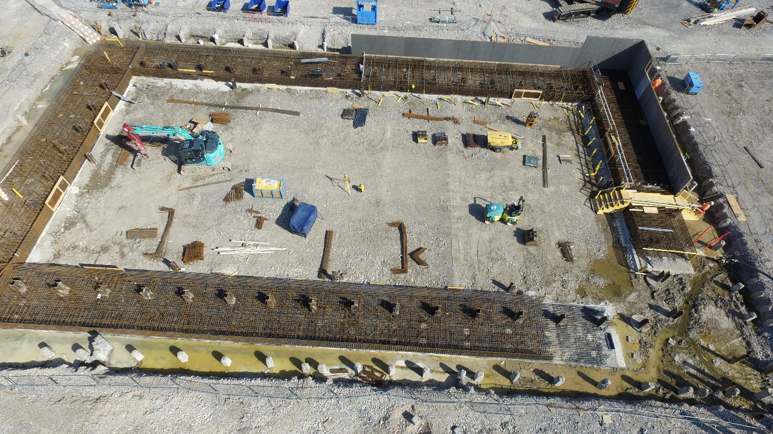
(a)
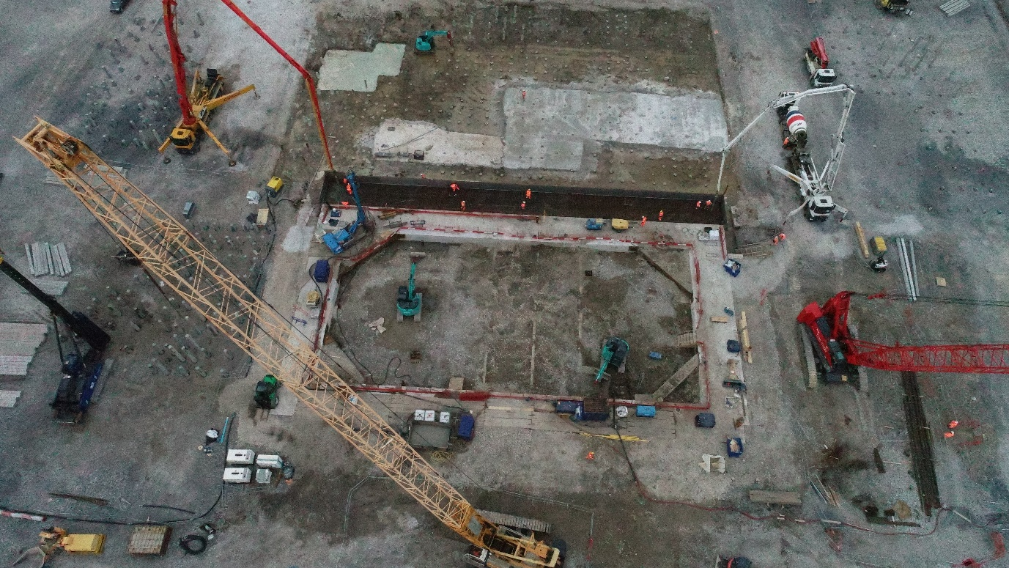
(b)
Figure R1 Drone photographs of the bunker taken (a) during capping beam construction and (b) taken post capping beam construction.

References

Clough, G. W., and T. D. O’Rourke. 1990. “Construction induced movements of in-situ walls.” In Geotechnical special publication: Design and performance of earth retaining structures (GSP 25), 439–470.
Peck, R. B. 1969. “Deep excavation & tunnelling in soft ground: State of the art report.” In Proc., 7th Int. Conf. of Soil Mechanics and Foundation Engineering, 225–281.
Robertson, P.K., 2009. Interpretation of cone penetration tests—a unified approach. Canadian geotechnical journal, 46(11), pp.1337-1355.

REVIEWER 2
The authors presented field observation of an excavation in Chester, UK, for the underground waste storage bunker. The excavation is quite regular in terms of the size, depth, geometry, and ground condition. It is almost greenfield condition adjacent to the excavation, so little concern is on the disturbance to the adjacent facilities. Based on the CPT tests adjacent to the retaining wall, the ground soil layers are quite flat and relatively uniform. No other lab test data are reported on the soil properties.
Response:
In hindsight, we agree with the reviewer that the information presented from the site investigation programme was lacking. The revised paper now includes significantly more data from the site investigation including density tests (see new Fig. 5), index tests (see new Fig. 5) and undrained-unconsolidated triaxial tests (see revised Fig. 3). The triaxial tests also allowed the authors to calibrate a site-specific cone factor for the cone penetration test data (revised Fig. 3). Given the word limit for this journal, we have reserved more advanced laboratory testing for a future paper involving complementary constitutive/numerical modelling.

The design and construction for this project look very conventional, and no detailed information was provided apart from the construction procedures. The field measurement program include the inclinometers close to the wall, vibrating wire strain gauges and optic fiber Bragg grating on the steel strut and RC beams, and piezometers in the soil. Continuous data measurement was reported for the major construction period.
In retrospect, the novel aspects of the project should have been made clearer in our previous submission.
The reviewer is correct that the excavation is regular in terms of its geometry and that there is little concern about disturbance to adjacent facilities. However, published case histories reporting the behavior of deep excavations in UK soft soils is almost non-existent, with data typically limited to the stiffer London Clays. The use of the tube and AZ sheet pile ‘combi-wall’ is certainly not typical for a deep excavation in a non-coastal environment (the first author is also a UK design engineer). This solution was chosen over a more conventional diaphragm or secant pile wall as neighboring projects had reported concrete volume losses of up to 50% during CFA piling works.
The novelty of this project is evidenced by the contractor’s (Ward and Burke Construction Ltd) direct financial support of this research to improve understanding of the behaviour of this unusual cofferdam, caused by unusual construction activities (internal piling) and in highly challenging ground conditions. A short note on this point has been included in the revised manuscript (lines 36 – 41).

(1) The field measurement program and data reported are rather conventional, comparing to the available case histories all over the world. There are lots of much better instrumented deep excavations, with good quality and comprehensive data to reflect the exaction behavior. Little new knowledge on the excavation performance can be learnt from this project.
Response:
There appears to be some confusion with respect to the novelty of our work. Novelty does not centre on the deployed instrumentation techniques. Rather, conventional instrumentation is used only as a means of extracting new insights into deep excavation behaviours associated with an unusual cofferdam design, unusual construction activities and in challenging ground conditions. Specifically, the novel aspects of our paper include:
- Case histories reporting the behavior of deep excavations in UK soft soils are almost non-existent with the vast majority of data relating to London Clay. The lack of information for these ground conditions prompted Ward and Burke Construction Ltd to fund this research directly to gain better understanding of excavation behaviours to de-risk construction (using live feedback of data).
- High quality field data for the combi-wall support system is very uncommon. For example, 16 of the 296 case studies reported in Long (2001) related to a combi-wall design, and only one involved a tube and sheet pile combination. With cofferdam installation technology having advanced significantly in recent years, the authors believe the combi-wall solution will become a more conventional method in soft and challenging ground to eliminate the risks associated with in situ concrete solutions in those conditions. It is therefore important to disseminate the findings of the present project towards future design method development.
- This monitoring work has provided valuable insights into the effects of internal vibratory piling within the excavation which resulted in significant increases to the lateral wall displacement and support structure loads. This should be an important consideration at the design stage for future deep excavation projects in similar ground conditions.
- Few published case histories provide detailed information on temperature effects on prop loads. The current method adopted by the industry to determine temperature induced loads for the design of temporary props is outlined in Gaba et al. (2017), and involves using an end fixity factor, FF (some literature uses β). The recommended values of FF are based on only 4 case histories – all of which involve the use of in situ walls in stiff London Clay. There are currently no recommended values of FF in soft soils due to a lack of reliable case history data. The temperature induced prop load data collected during this project provides a valuable contribution to the databases in Twine & Roscoe (1997) and in Gaba et al. (2017).
- To the authors’ knowledge, this is the first paper to report the use of fibre bragg gratings (FBGs) to monitor the structural performance of an underground RC foundation slab. Typically, discrete embedment type VW strain gauges are used for this application, whereas FBGs provide pseudo-continuous strain profiles. The authors also report a novel technique to distinguish temperature and mechanical strain effects from the FBGs.

(2) The conclusions generated from this project are not significant for research purposes. In addition, the conclusions are rather general and weak. It seems like a normal construction project, and very little research is involved.
Response:
Having reviewed our previous submission, the reviewer’s comment is valid and our conclusions were a bit too high-level. All conclusion points have now been re-written to draw out the specific insights achieved from the monitoring activities. The authors now feel quite strongly that the conclusions are reflective of high-quality research and provide valuable and novel insights into the behavior of deep excavations in soft ground. Indeed, this level of insight is consistent with other monitoring papers published in Géotechnique: Ng et al. (2012), Li et al. (2018) and Nejjar et al. (2021).

(3) The manuscript was not well written, and the general structure is a bit messy.
Response:
The authors are surprised by this comment given that both Hensman and Sheil are native English speakers and the manuscript was checked carefully prior to submission. We note Reviewer 1’s comment that the case history was ‘high quality’ and describes the monitoring data as being ‘clearly presented’. Reviewer 3 also described the work as ‘well documented’. The structure we adopt is consistent with similar Géotechnique work e.g. Ng et al. (2012) and Nejjar et al. (2021). The structure was devised very carefully for reader accessibility.
The authors welcome the reviewer to highlight specific instances of poor writing/structure and we shall gladly review. Our resubmission has again been proofread carefully.

References
Long, M., 2001. Database for retaining wall and ground movements due to deep excavations. Journal of Geotechnical and Geoenvironmental Engineering, 127(3), pp.203-224.

Twine, D. and Roscoe, H., 1997. Temporary propping of deep excavations-guidance on design. Construction Industry Research and Information Association.

Gaba, A., Hardy, S., Doughty, L., Powrie, W. and Selemetas, D., 2017. Guidance on embedded retaining wall design. London, UK: Ciria.

Nejjar, K., Dias, D., Cuira, F., Chapron, G. and Lebissonnais, H., 2021. Experimental study of the performance of a 32 m deep excavation in the suburbs of Paris. Géotechnique, pp.1-11.

Li, Z., Soga, K. and Kechavarzi, C., 2018. Distributed fibre optic sensing of a deep excavation adjacent to pre-existing tunnels. Géotechnique Letters, 8(3), pp.171-177.

Ng, C.W.W., Hong, Y., Liu, G.B. and Liu, T., 2012. Ground deformations and soil–structure interaction of a multi-propped excavation in Shanghai soft clays. Géotechnique, 62(10), pp.907-921.

REVIEWER 3
I consider this to be a good and well-documented case record, but I have some comments:
The presentation of soil conditions lacks details. There is for instance no soil profile giving index parameters (total unit weight, water content, plasticity etc.), and no results from more advanced laboratory testing (oedometer, triaxial testing ….) .
Response:
The authors acknowledge that the description of the site ground conditions provided in our previous submission lacked detail. For brevity, only a small proportion of the results from the site investigation were presented. The authors have now included significantly more information from the site investigation including:
- Undrained shear strength, s_{u} data determined from of a series of undrained-unconsolidated laboratory triaxial tests performed on samples taken from the cohesive ground layers (see revised Fig. 3). The s_{u} laboratory test data has been used to calibrate a site-specific value of the cone factor N_{kt}.
- Measured shear wave velocity, V_{s} and inferred stiffness data from the SCPT (see new Fig. 4). The measured V_{s} and stiffness data are compared to that inferred from standard CPT measurements using the method in Robertson (2009).
- The results of a series of laboratory density and index tests performed on samples taken from the cohesive ground layers (see new Fig. 5).
Due to the word count for this journal, the authors will include the results of the more advanced laboratory elemental testing (consolidated-undrained triaxial tests and oedometer tests) in a follow up paper based on the development of a numerical model for the deep excavation in PLAXIS 2D/3D.

The undrained strength profile interpreted from the CPT's do not tell what Su that is interpreted (triax compression?) and does not address shear strength anisotropy. It is only based on the Mayne approach.
Response:
The authors have explored the anisotropy of soil strength using more complex laboratory elemental tests. Due to word count limits, the authors will present the results of more complex laboratory testing in a follow up paper based on numerical modelling of the excavation using PLAXIS. The authors feel that while the more detailed laboratory elemental testing is unlikely to be necessary for interpretation of the monitored data, it will certainly be necessary for constitutive and numerical model development.

The references to past experiences with excavations in soft ground lack references to the extensive experiences from Nordic countries.
Response:
The authors thank the reviewer for this helpful suggestion. We have undertaken additional reading into relevant published case histories in Nordic countries and have indeed found some particularly useful cases in Norway and in Gothenburg/West Sweden. A selection of these cases has now been cited in the revised manuscript (lines 20 – 22).

The paper could have benefitted from including numerical analyses of the performance using PLAXIS 2D or even 3D but that could be for another paper?
Response:
The reviewer makes an important point. Unfortunately the word count prevents us from including numerical analysis work in this paper but this will be certainly the subject of a future publication.

References

Robertson, P.K., 2009. Interpretation of cone penetration tests—a unified approach. Canadian geotechnical journal, 46(11), pp.1337-1355.

